**Rational Quality Management to Rational Clear Quest Integration**

Although with the Jazz work items component you can submit and track defects, tasks, and enhancement requests, your team might need to also use a ClearQuest user database and work with ClearQuest records directly from the Jazz environment. With the ClearQuest record and Jazz work item bridge, you can create, view, and modify ClearQuest records, run ClearQuest queries, and associate ClearQuest records with Jazz work items, all in the IBM® Rational Team Concert Web client.

**Pre-requisites:**

* Quality Management application configured with the Jazz™ Team Server.
* Rational ClearQuest Web Server component from Rational ClearQuest version 8.0 or later on the computer where you plan to set up your web server. You can install the ClearQuest Web Server on the same machine as the Quality Management application or on a remote machine.
* Configure the integration from Rational ClearQuest, being sure to apply the OSLCLinks package to your ClearQuest schema
* You have a Rational Quality Manager - Quality Professional Client Access License (CAL).
* You are using public host names rather than aliases or proxies.
* You have disabled pop-up blockers in your browser.

**Applying ClearQuest OSLCLinks Package:**

Right Click on the database connection to which you want to install OSLCLinks package and select install package.

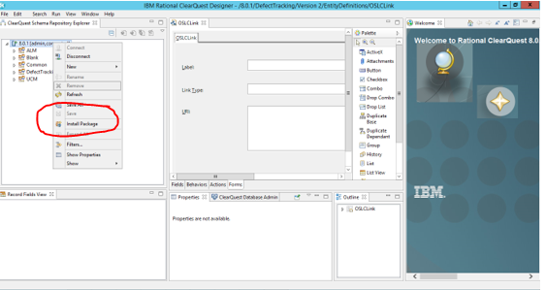

You will find the list of packages available.

Search for OSLC and select 1.2 as shown in figure.

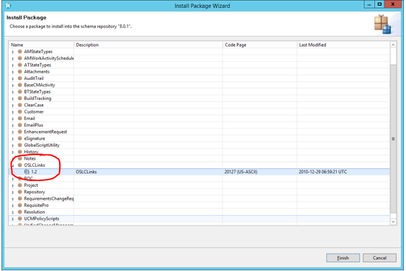

Select the record types and click on finish. You will find the below window if installation is successful.

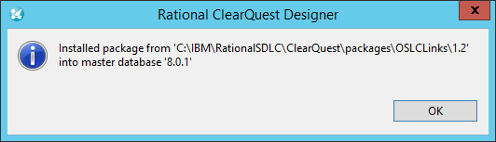

You can find the changes in schema under Record Types-stateless as shown below.

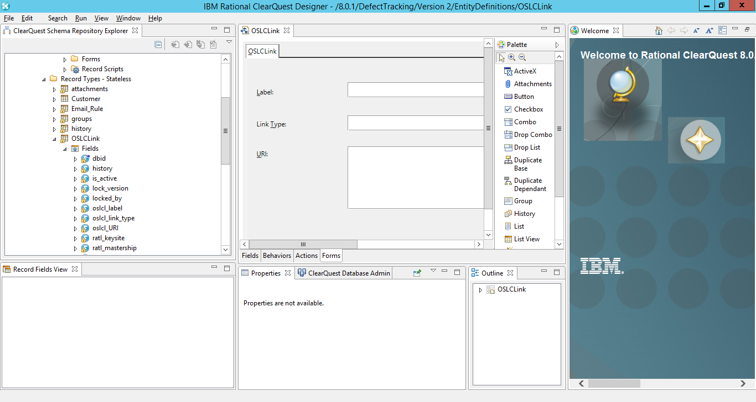

Add a global Perl script named OSLC_CQ_State_Mapping and provide an implementation.

1. Navigate to the **Global Scripts** > **Perl node** associated with the schema, right click, and select **Add**.
2. Enter the following text in the **Hook name** field and then click **OK**: OSLC_CQ_State_Mapping
3. Add hook code to the OSLC_CQ_State_Mapping script.

sub OSLC_CQ_State_Mapping {

my ($myentity, $hook_type) = @_;

my $state = $myentity->GetFieldStringValue("State");

if ($hook_type eq "Validation") {

if (($state eq "Assigned") || ($state eq "Opened")) {

$myentity->SetFieldValue("oslc_cm-inprogress", "1");

} else {

$myentity->SetFieldValue("oslc_cm-inprogress", "0");

}

if ($state eq "Closed") {

$myentity->SetFieldValue("oslc_cm-closed", "1");

} else {

$myentity->SetFieldValue("oslc_cm-closed", "0");

}

}

}

This script is called by the initialization and validation hook of the OSLC_State_Predicates action of a Defect record. The script has two parameters: the current entity and the hook type. Depending on your requirements, you can add different codes according to the value of the hook type parameter. The example script shows a validation hook.

1. Click **Finish**. The schema revision is checked in.
2. Upgrade the user database.
3. Verify the schema changes:
   1. Use your ClearQuest client to log in to the user database.
   2. Edit the All Defects query and add the following display fields: oslc_cm-inprogress and oslc_cm-closed.
   3. Run the All Defects query.
   4. Select a defect in the query results that is in the Submitted state.
   5. Close the defect and verify that oslc_cm-closed equals 1 while the other fields with names prefixed with oslc_cm equal 0.
   6. Reopen the defect and verify that oslc_cm-inprogress equals 1 while the other fields with names prefixed with oslc_cm equal 0.

**Set up cross-server communication with Rational ClearQuest in RQM:**

**Procedure**

Point your browser to https://*[fully qualified hostname]*:9443/qm/admin.

In this case it is: <https://bsd-pc1528497:9443/qm/admin>

In the Communication pane, click Consumers (Inbound).

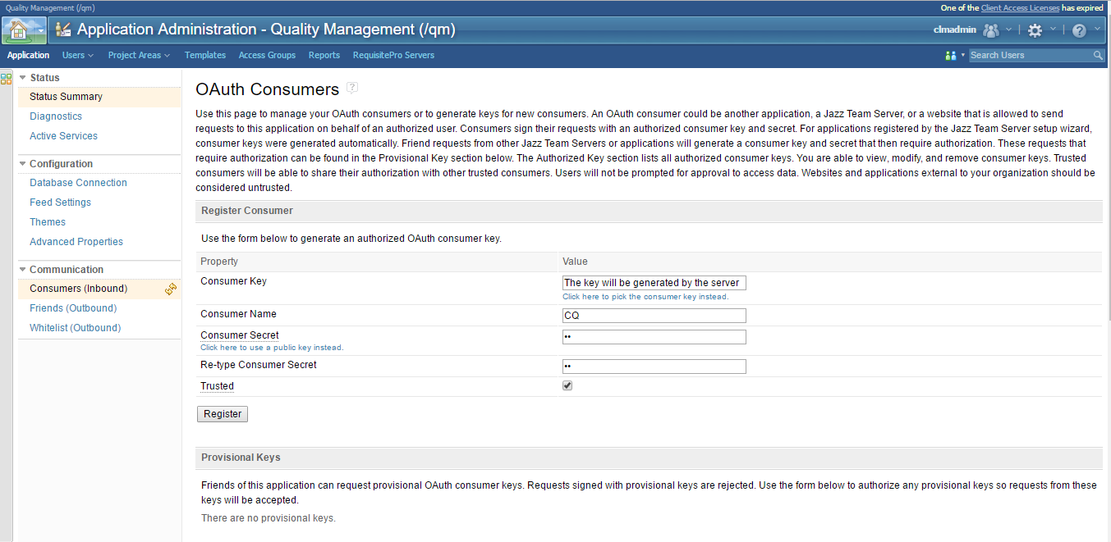

Provide the name that you want to use to identify the Rational ClearQuest web server.

Type any phrase in consumer secret and Re-type Consumer Secret Fields.

Check Trusted and Click on Register.

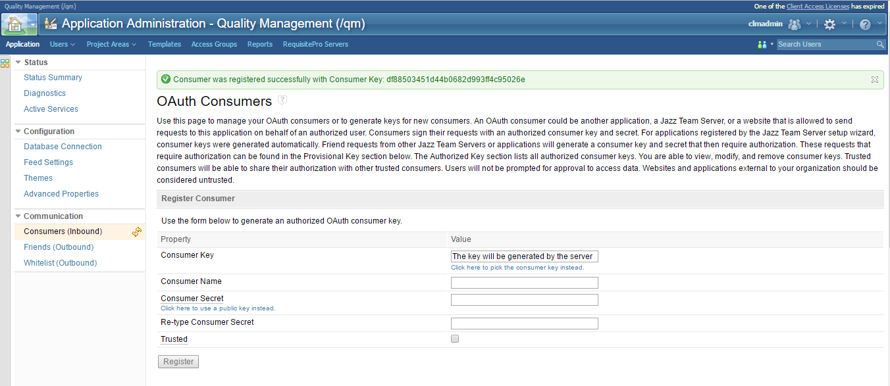

The consumer key will be automatically generated and you can find that ClearQuest is added in the Authorized keys list.

You can add a user by editing the details of ClearQuest web server.

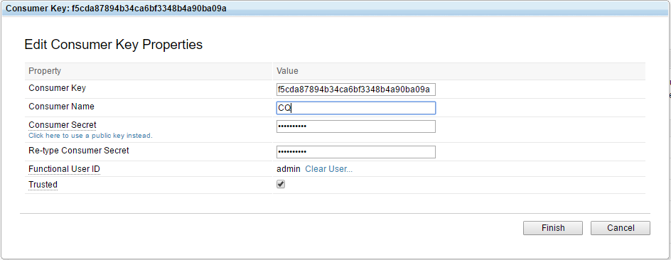

In the Communication pane, click Friends (Outbound). The Friends page opens.

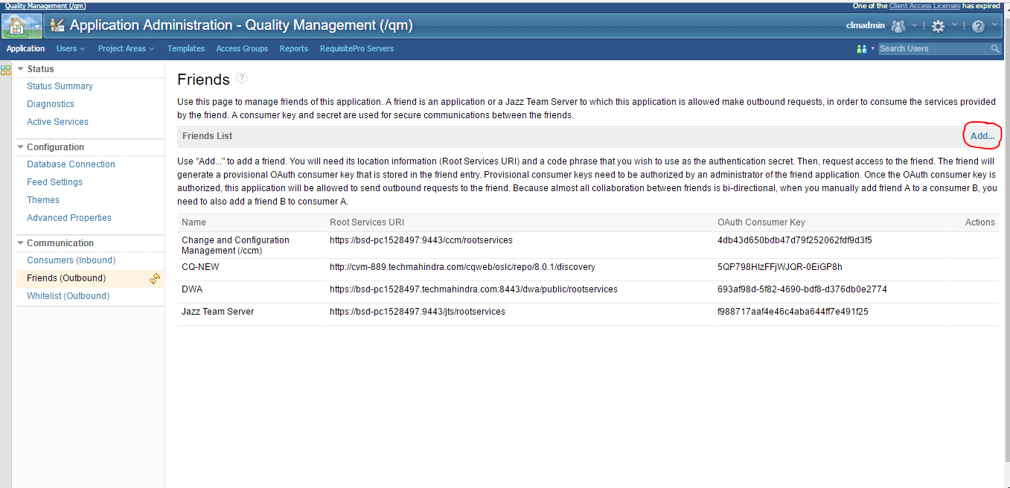

Click **Add**. The Add Friend window opens.

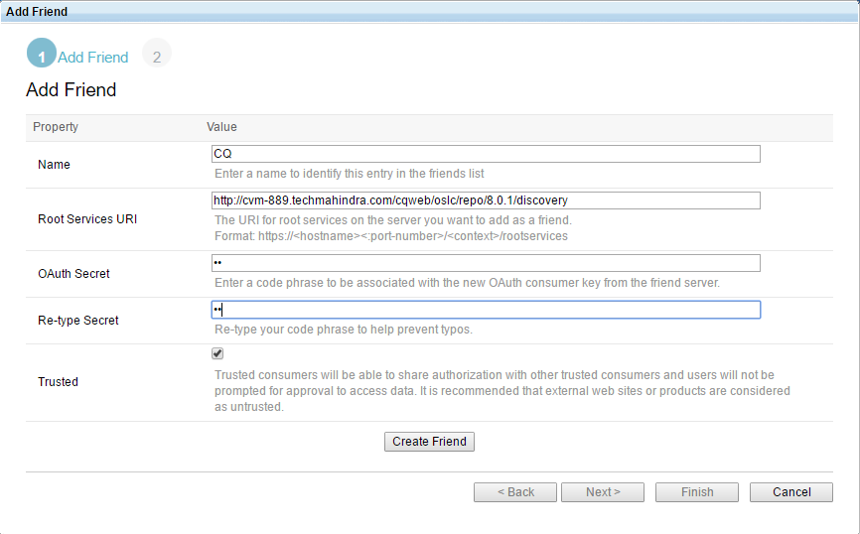

For Name, type the name that you want to use to identify the Rational ClearQuest web server.

For Root Services URI, type the concatenation of the public URI and the Rational ClearQuest discovery context information. For example, https://*<cq-hostname>*/cqweb/oslc/repo/*<schema-repository>*/discovery, where *<cq-hostname>* is the name of your ClearQuest web server and *<schema-repository>* is the name of your ClearQuest schema repository.

Here it is: <http://cvm-889.techmahindra.com/cqweb/oslc/repo/8.0.1/discovery>

For OAuth Secret, enter a code of your choice to be associated with the new OAuth consumer key of the server.

Note: In this step you do not enter the key itself; you enter a shorter phrase that will be associated with the actual key.

In the Re-type Secret field, retype the OAuth Secret code phrase.

Select Trusted to designate this as a Trusted consumer. Trusted consumers can share authorization with other trusted consumers and do not require user approval to access data.

Click **Create Friend**.

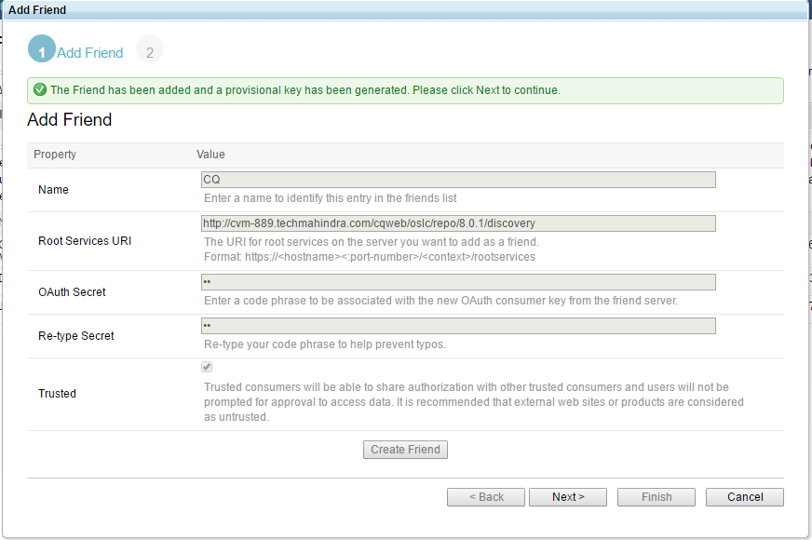

If the connection to the root services URI was successful, you will see a message confirming that the Friend was added and that a provisional key was generated.

Click **Next**.

Click the Grant access for the provisional key link to log in to the Rational ClearQuest web server as an Administrator and approve the provisional key.

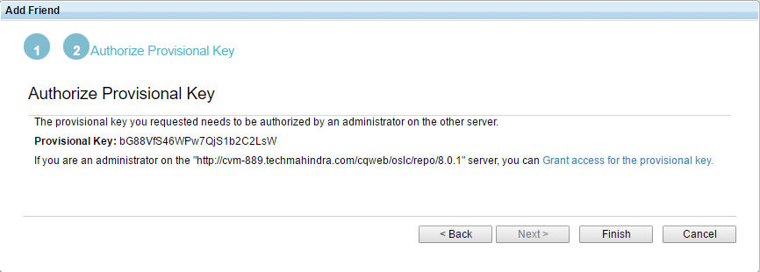Click **Finish**.

You can also approve the provisional key later. Click**Site Administration>OAuth Consumer Management**. You can find the list of Provisional keys that are in **pending** state. You can **Approve** or **Reject** it.

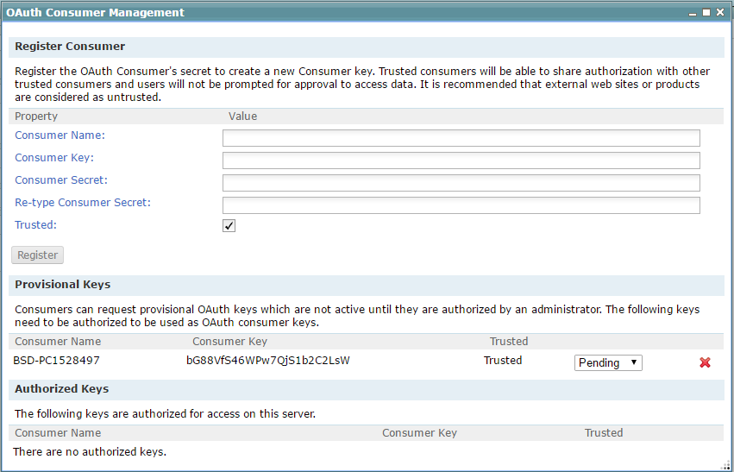

If the Provisional key is approved, it will be displayed in the list of Authorized keys.

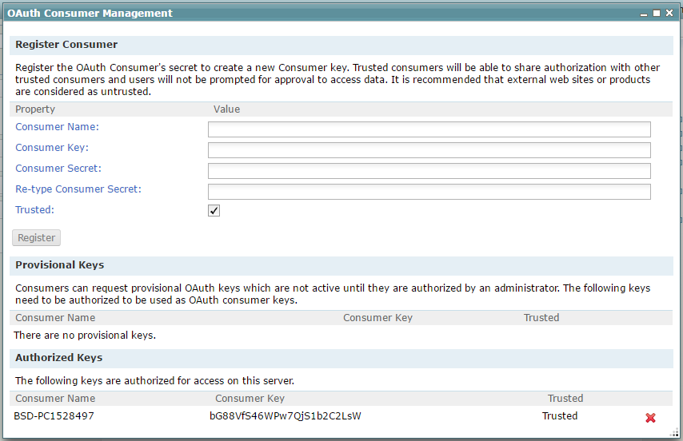

**Configuring ClearQuest Web server for CLM integrations:**

You must perform several configuration tasks on the ClearQuest Web server and the Jazz server to enable the Collaborative Lifecycle Management (CLM) integrations with Rational Team Concert, Rational Quality Manager, and Rational Requirements Composer

Use the Cross-Server Communication window of the Site Configuration interface to specify a target OSLC service provider with which you want to establish server-to-server communication. Enter the location information of the target server and a code phrase to use as the OAuth secret. Then request access to that server to create an OAuth consumer key and store the information in the friends list. Once the OAuth key is authorized by the other server, the ClearQuest Web server can interact with the target server.

**Procedure**  
  
Log on to ClearQuest Web as a user with Super User privileges.

Click Site **Administration > Cross-Server Communication** on the ClearQuest Web toolbar. The Cross-Server Communication window opens. 

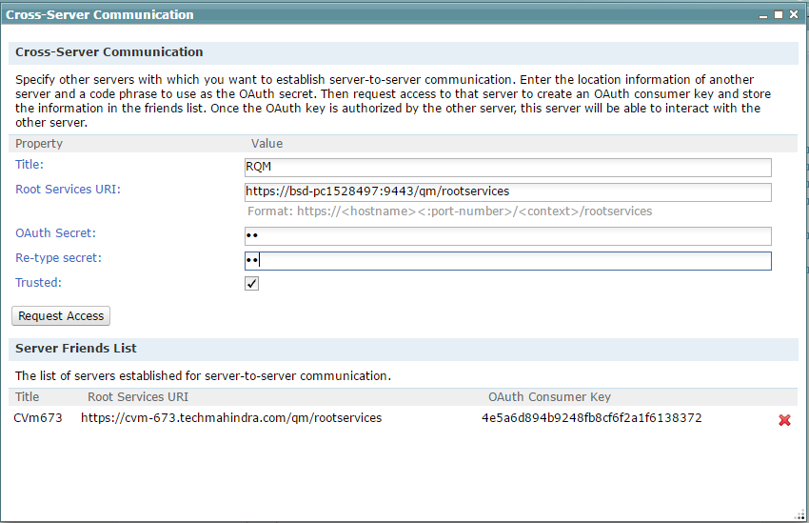

Specify the requested information about the target server with which you want to establish communication.

In the Title field, enter a title to identify a target server.

In the Root Services URI field, enter the URI for the target root services of the application that you want to add as a friend by using the following format:

For Jazz server-based products:   
https:// *friend-server*: *port-number*/ *context*/rootservices

***friend-server***

Host name of the friend server.

**Attention**: Be sure to specify the host name by using the public URL with a fully qualified domain name. Do not specify the IP address.  
 ***port-number***

Port number on which to access the server.

***context***

Application context. This is a configurable parameter.

Default value for Rational Quality Manager-**qm**

Here the **root services uri** is: https://bsd-pc1528497:9443/qm/rootservices

In the OAuth Secret and Re-type Secret fields, enter an OAuth Secret code phrase to associate with the new OAuth consumer key. 

**Attention**: In this step, you do not enter the key itself; you enter a shorter phrase to associate with the key.

**Optional**: Select the Trusted check box. Trusted consumers can share authorization with other trusted consumers and do not require user approval to access data.   
**Attention**: For external products or web sites, it is a best practice to clear the Trusted check box.

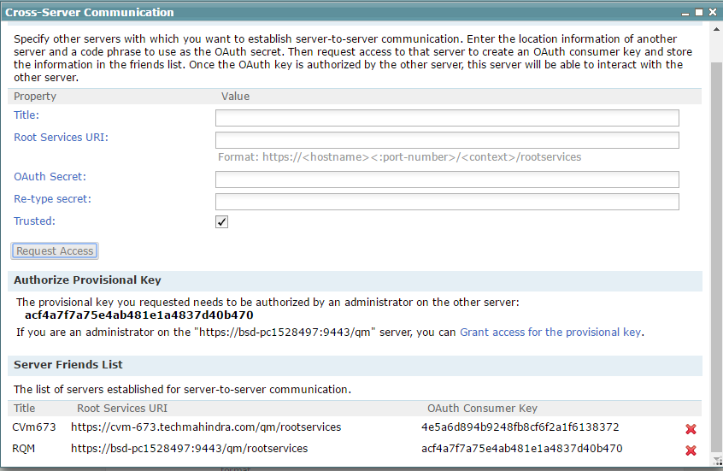

When you click on **Request Access**, the Quality Manager server is added in the Server Friends List and a provisional key is generated for Rational Quality Manager Server.

Click on Grant access for the provisional key to approve the provisional key. Provide the credentials for RQM when prompted and **Approve** the provisional key.

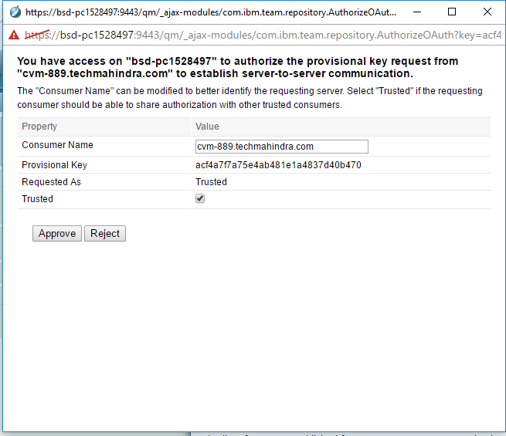

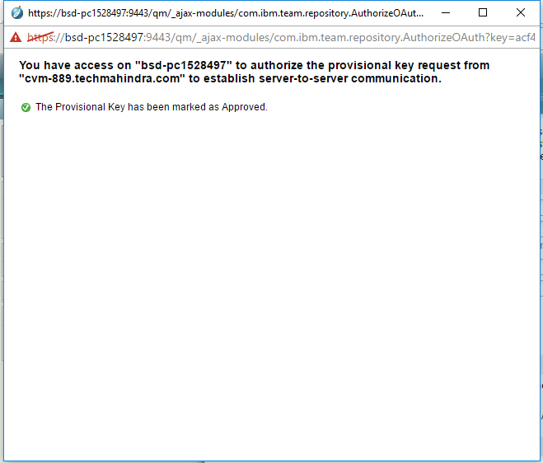

You will see that the Provisional Key has been marked as Approved.

**Configuring project relationships:**  
After configuring the ClearQuest Web server for cross-server communication, configure project relationship links. These links represent relationships between projects and service providers such as projects on other servers. Link types reflect the nature of the service that a provider makes available to the project. Establishing a project link enables linking between artifacts in the project and artifacts that the service provider makes accessible.   
  
**Procedure**  
  
1. Click **Site Administration > Project Relationships** on the ClearQuest Web toolbar. The Project Relationships window opens.  
  
2. Select a server from the Server list to create a link with the ClearQuest Web application. An authentication window might open that prompts for credentials for the remote service. Enter the user name and password and then click **OK**. 

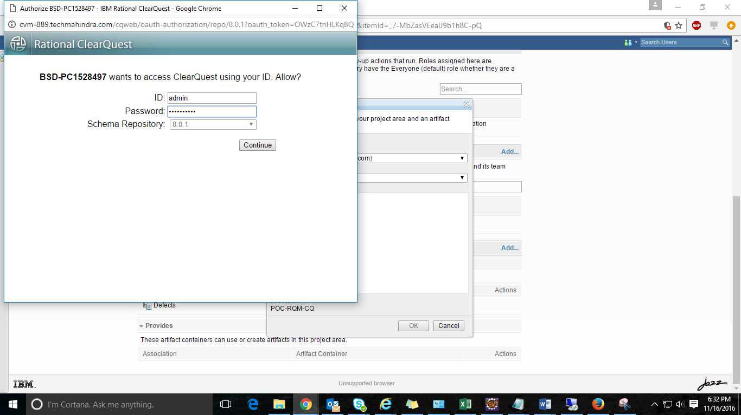

3. Select a service provider from the Service Providers list.   
  
4. Click **Add** to add the project relationship link. Project relationship links appear in the Project Relationship section of the page.

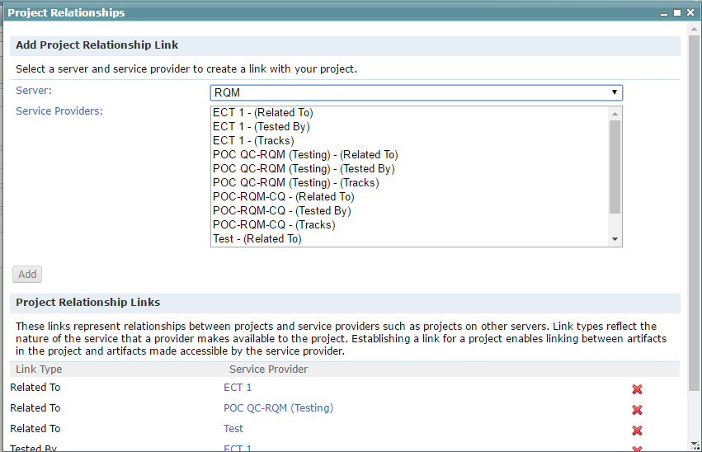

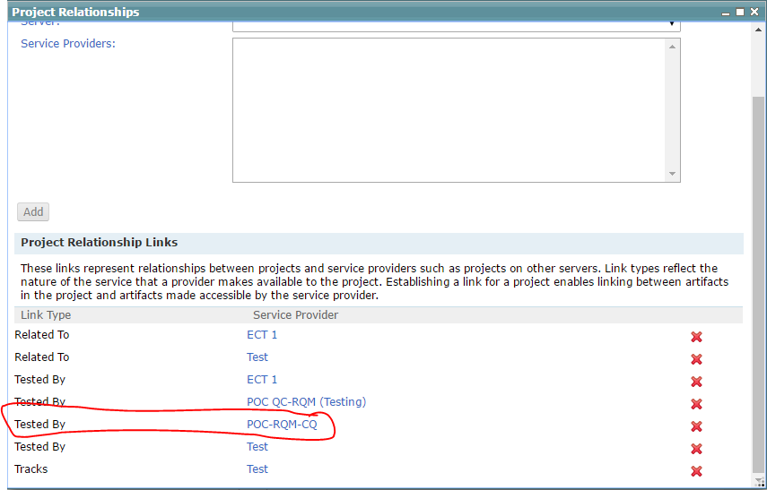

POC-RQM-CQ is now visible in the Project Relationship Links.

**Add the CQ Artifact container in RQM:**

In the Quality Management application, set up a link between the Rational ClearQuest user database and the Quality Management project area.

Click the **Admin** icon (Administration), and then click **Manage Project Areas**.

Click to open the project area that you want to configure.

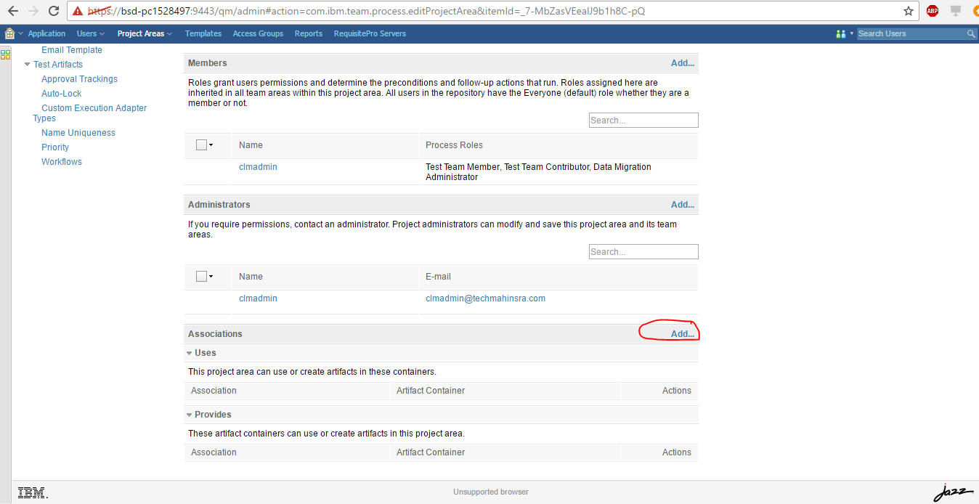

Scroll to the bottom of the page and in the Associations section, click **Add**. The Add Association page opens.

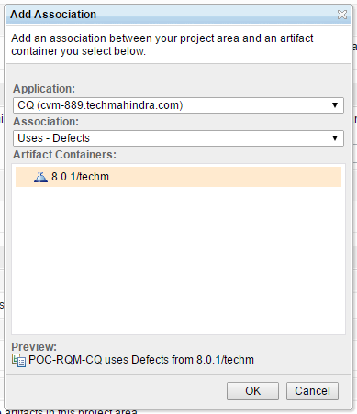

In the Application list, select your Rational ClearQuest web server and log in to the server when prompted.

In the Association list, select Uses - Defects to list the Rational ClearQuest databases on your server.

**Important**: Do not select the Provides - Change Management option.

In the Artifact Container section, click to select your Rational ClearQuest databases.

Click **OK** and then save the changes to the project area.

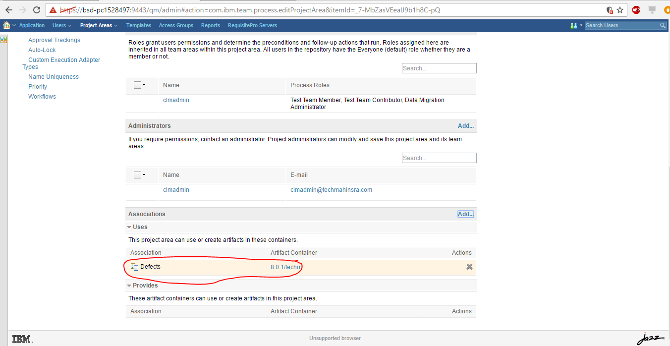

You can see that Artifact container has been added in Associations.

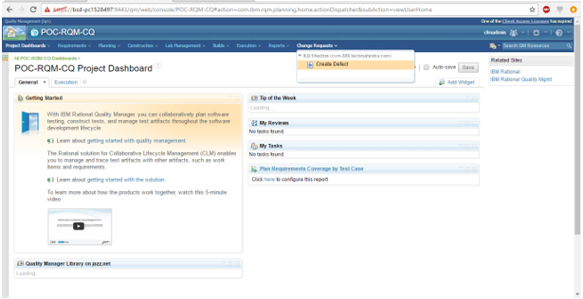

**Creating Defect in RQM:**

1. Initialize the connection.
   1. Connect to the project area by pointing your browser to https://[fully qualified hostname]:9443/qm/web.
   2. In the main menu, click **Change Requests > Create Defect**.
   3. Select Rational ClearQuest as your change management provider.

A connection window opens.

* 1. Type the user ID and password for the Rational ClearQuest repository and database.
  2. Click **Log In**.

A defect submission form is displayed.

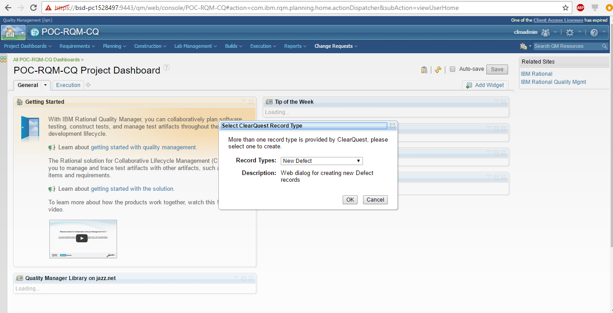

* 1. Complete the form and click **Save** to submit the defect.

Changes in Schema

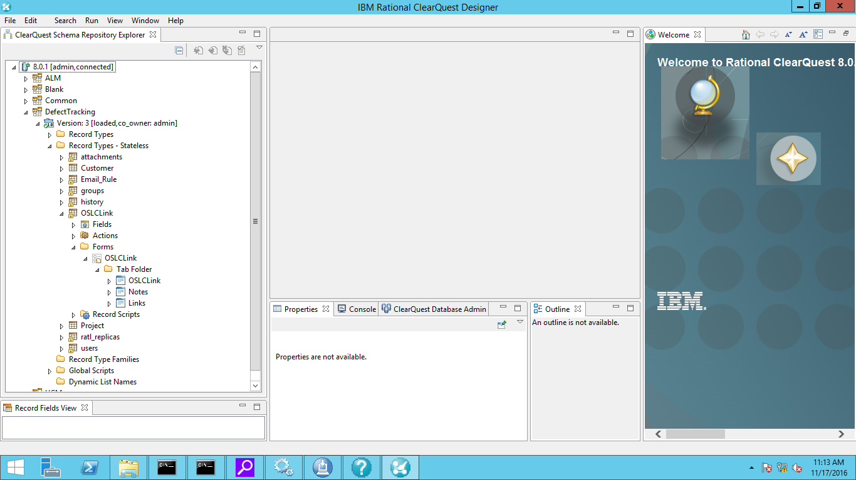

Defect forms and tabs

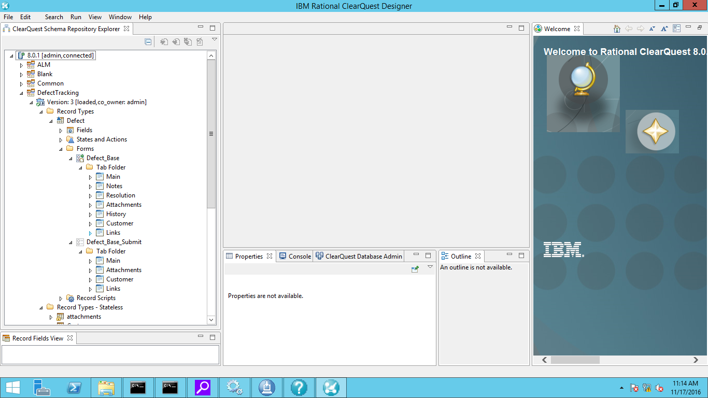

Defect base form as Record form and submit form.

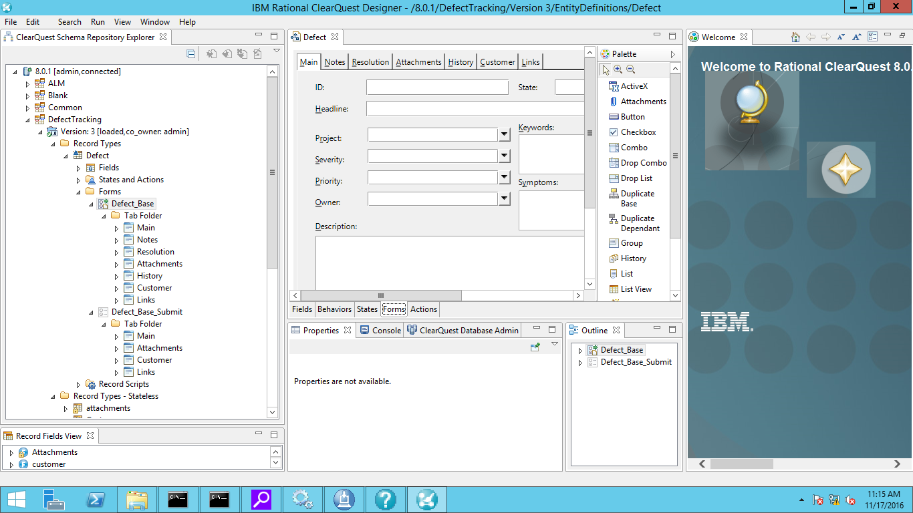

Defect submission form in CQ(Couldn’t find links tab)

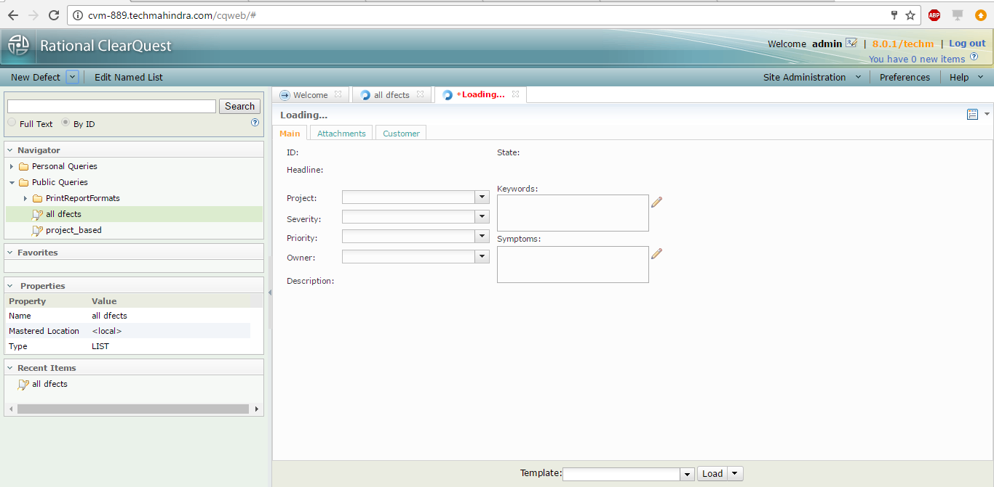

Record type selection form in RQM:

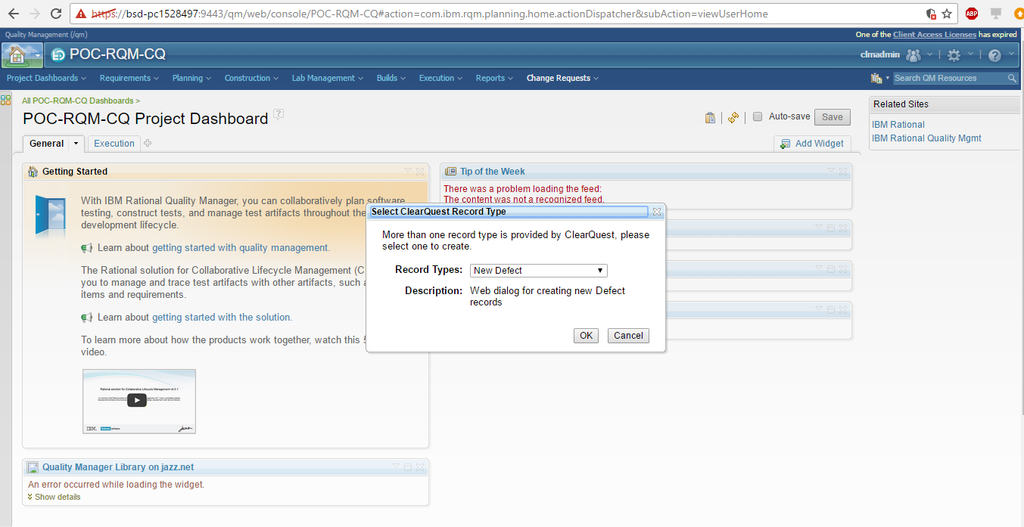

Defect submission form in RQM:

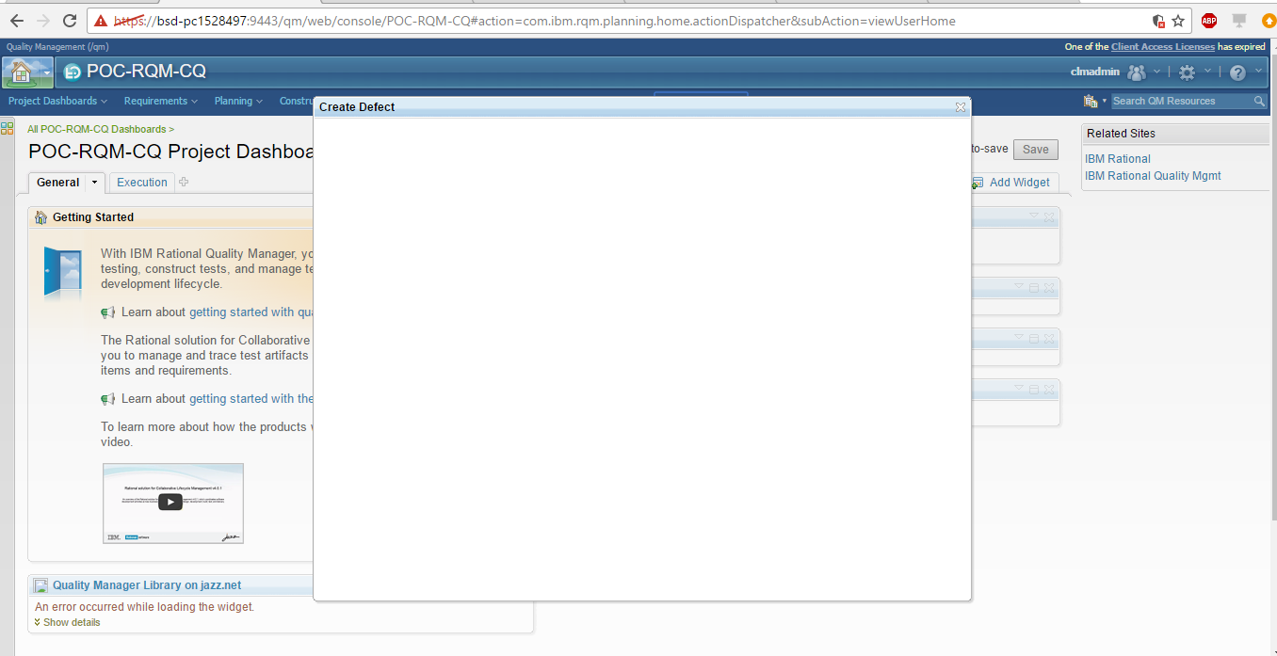

Frequent error in CQ:

